1. **To apply AWS Educate using your school email.**

Before using aws educate, you must have an AWS account. So how to create an AWS account you can read this file:



Applying link is below:

<https://aws.amazon.com/cn/education/awseducate/>

1. Open this page for aws educate：

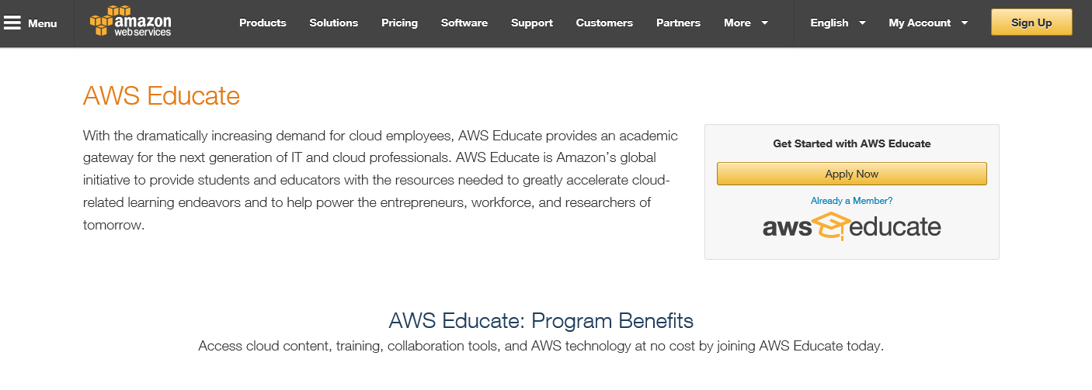

Click “Apply Now” will turn this page:

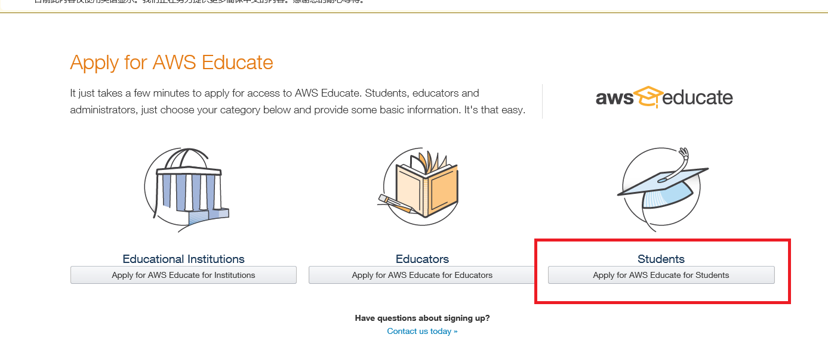

Click “Apply for AWS Educate for Students” and fill out personal information

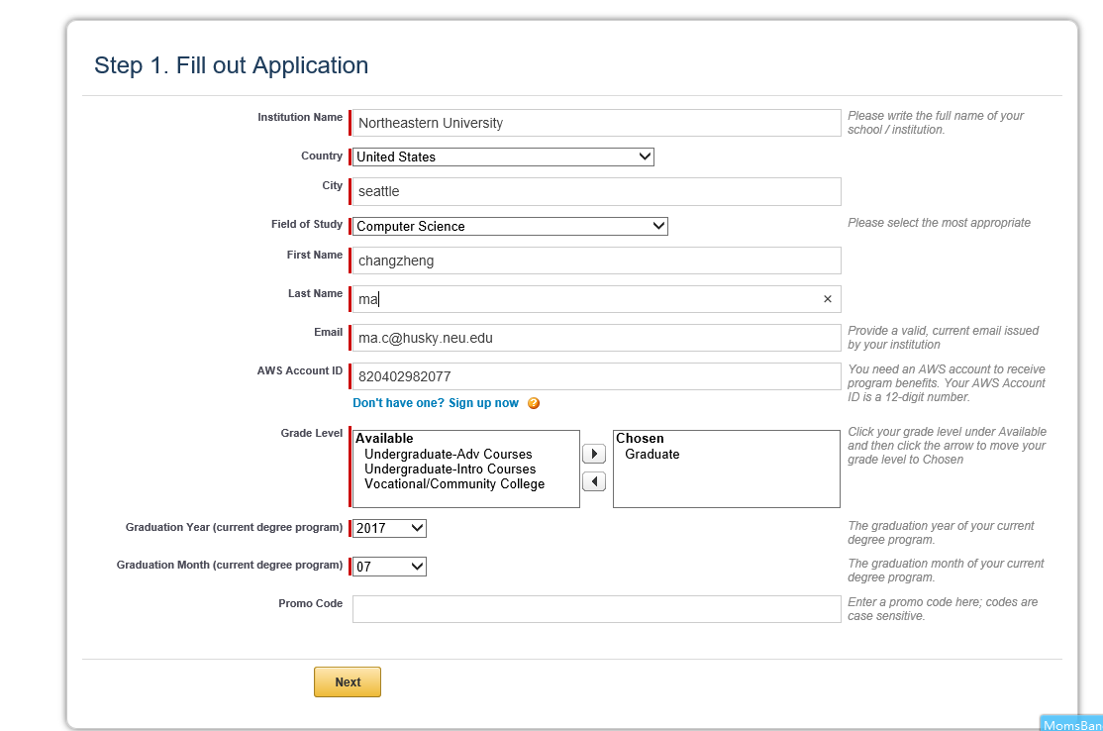

Note: You must fill out your AWS Account ID which you just create and your school email. This will create the contact with your AWS account and your AWS Educate.

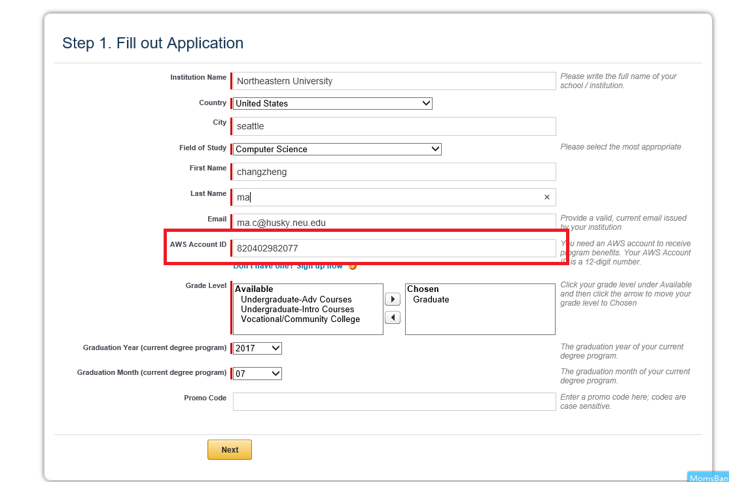

This AWS Account ID is your previous constructed AWS account id, and you need login in your AWS account to see it:

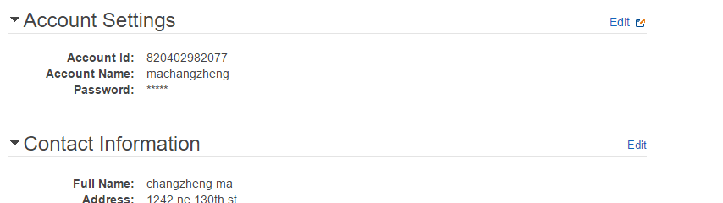

This means this educate will be associated with your AWS account.

After make sure fill out the educate information, then click “Next”. In this page, you will input the verify code getting from your school email like:



In this email, you will see a Verification Code and fill it into the page and click “next”.

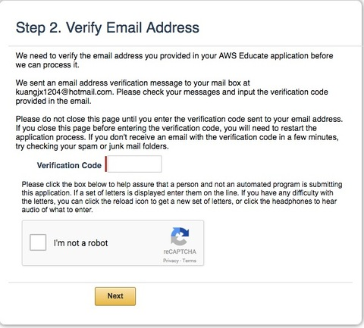

Click “next” to go into accept terms page and finish it.

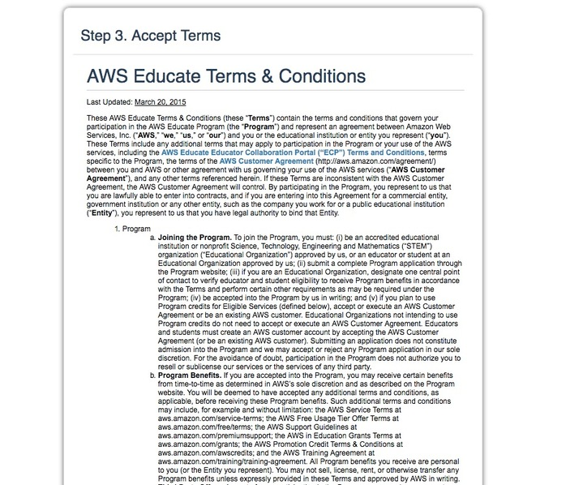

Then wait an email from AWS Educate will tell you whether this application success.



1. After you finish the steps of this application, you are able to redeem your credit amount. These step is:
2. Login your aws account;

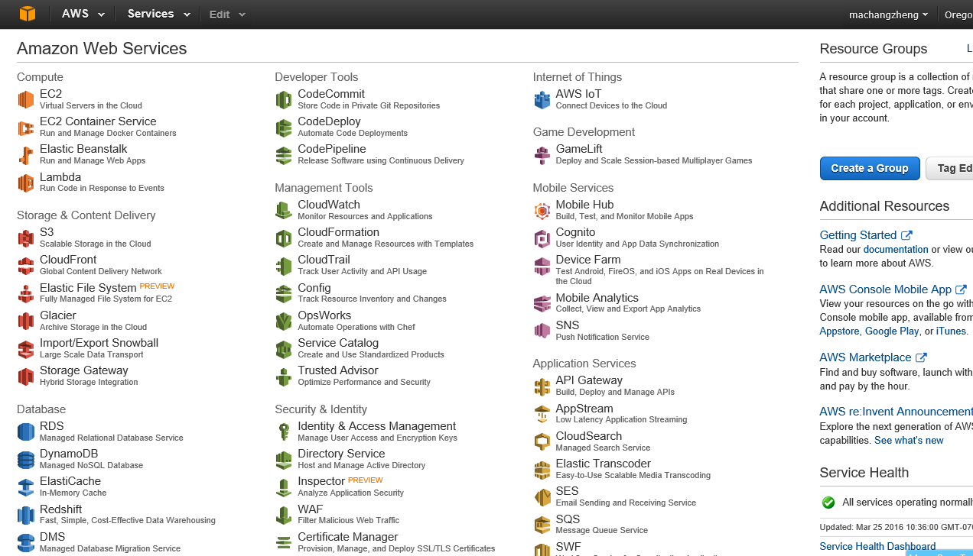

1. Click the username of the right-top corner

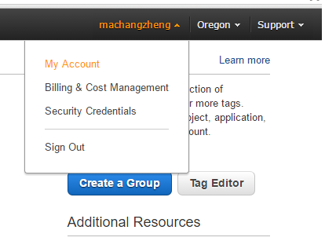

1. Click “My Account” go into your AWS account settings.

Select “Credits” to input your Credits code among your confirmation email and click “Redeem” button to use it.

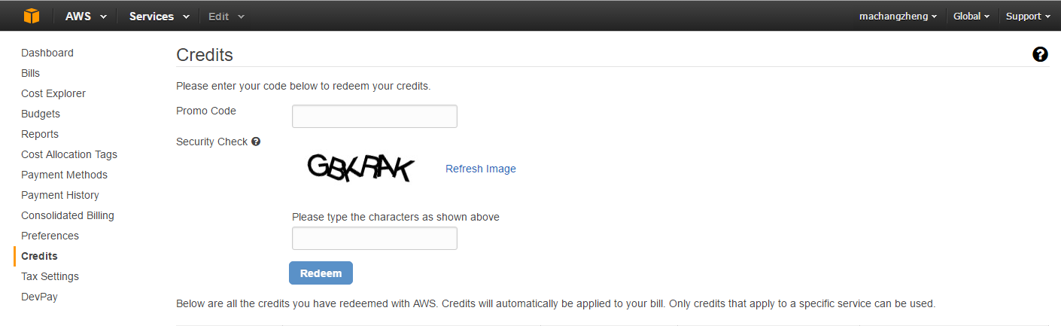

1. **Create a DB instance**

Login your aws account;



Select “RDS”

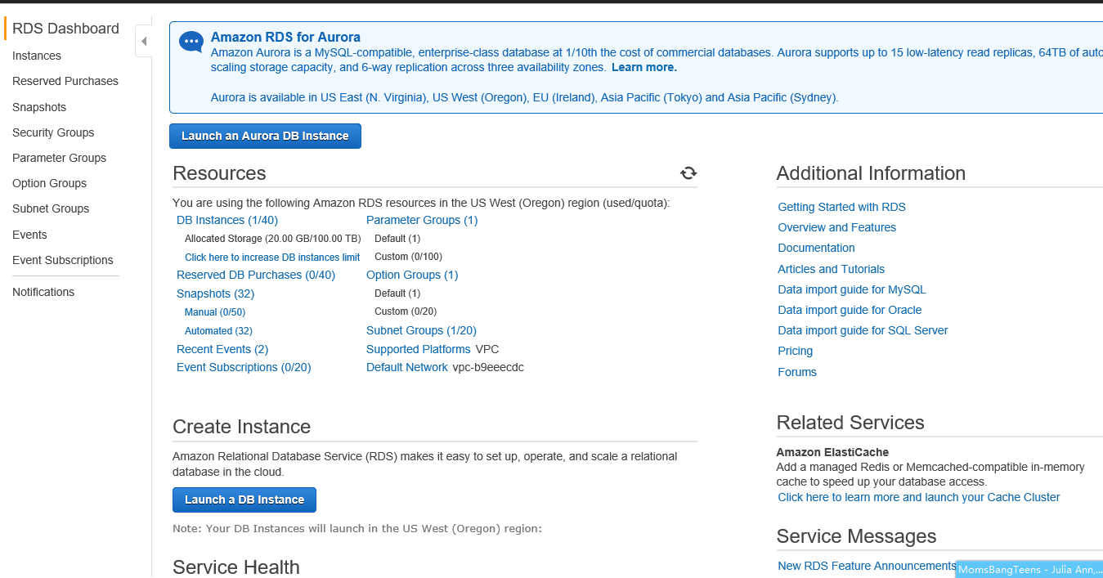

Select and click “Launch a DB Instance” button

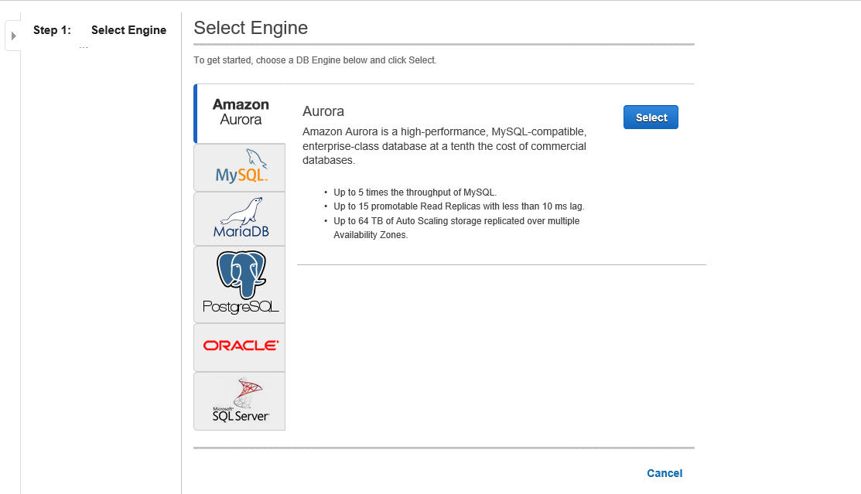

Select Engine, we select “SQL Server”

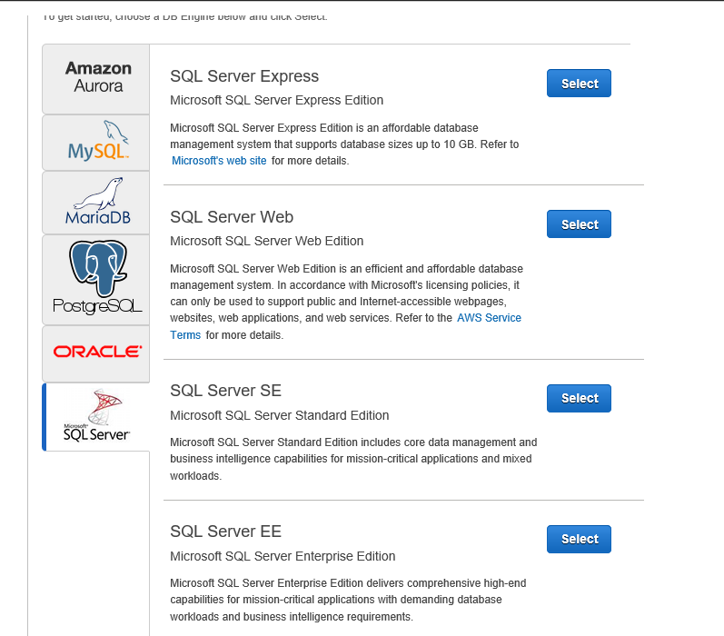

Select Standard Edition

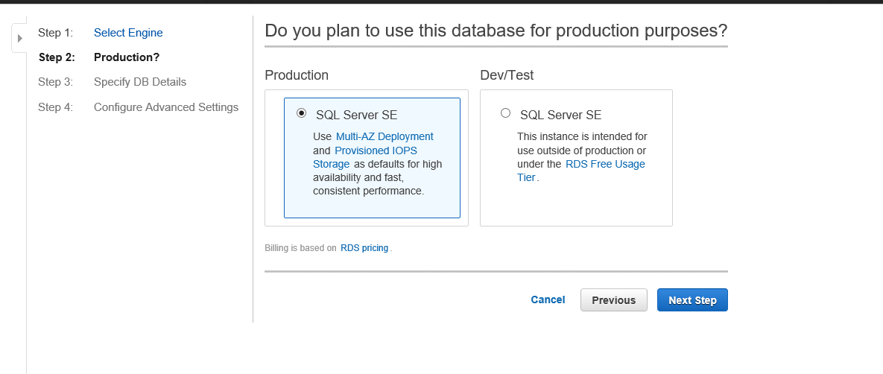

Select Prodcution or Dev/Test, for our intern project should select Dev/Test

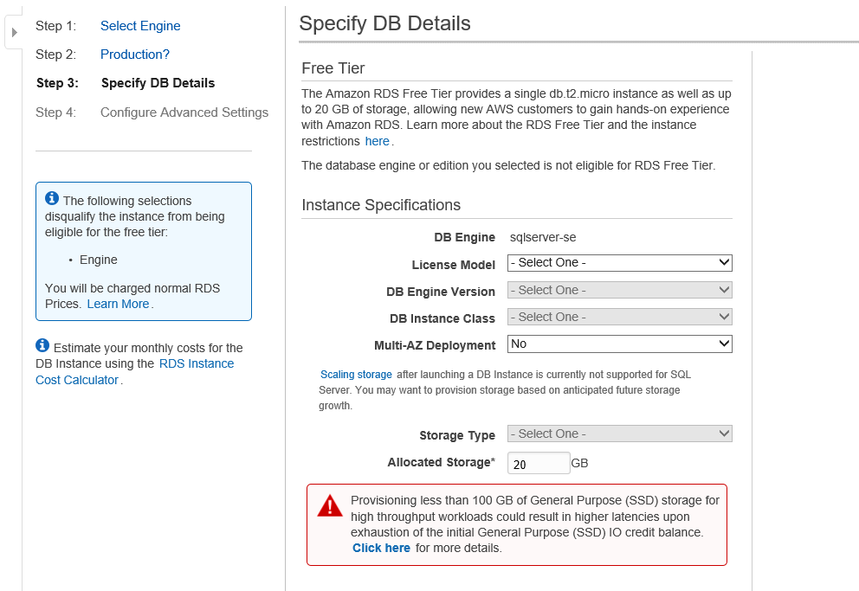

Configure DB type and set DB master user infotmation(include DB name, username and password):

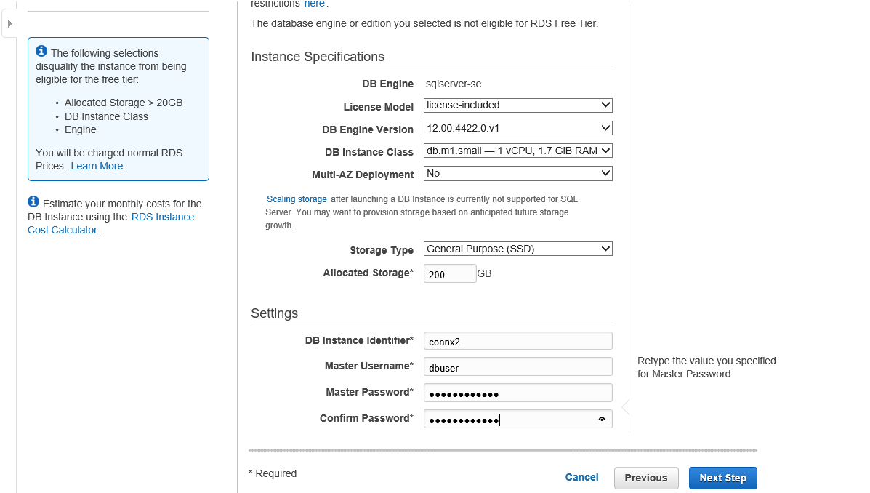

Note: After you finish this instance creating, when you test the connection of this DB instance, you must provide these information (DB name ,username and password).

Click “Next Step” to configure security parameter:

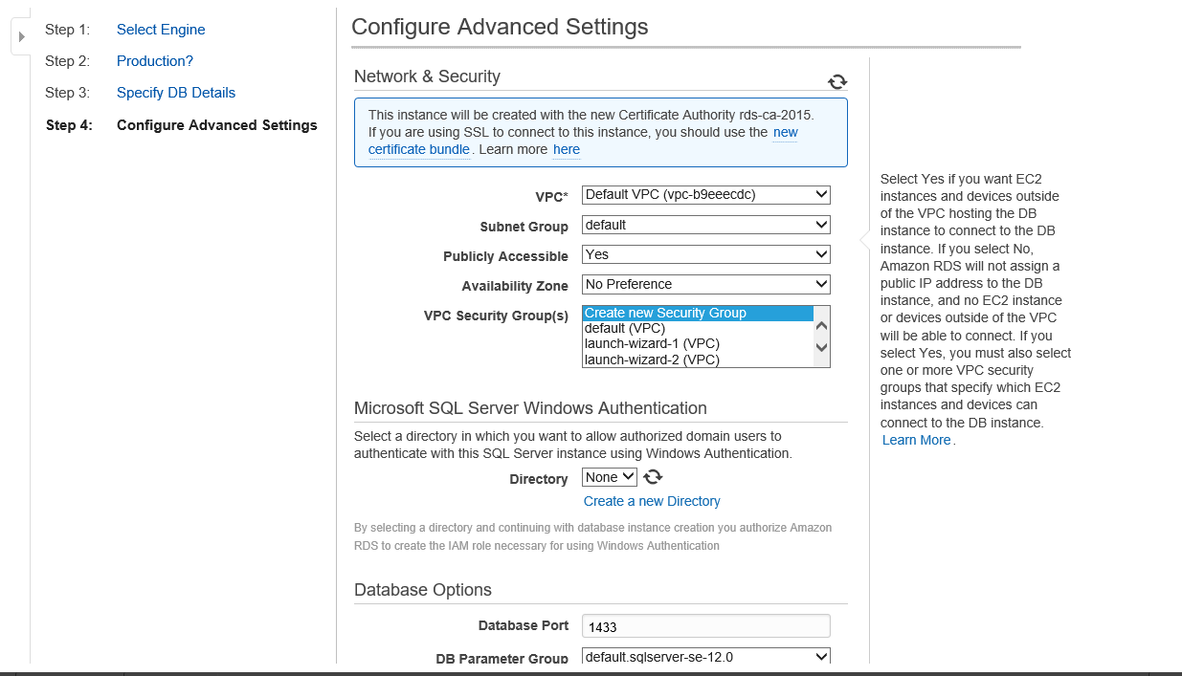

For Database set your preference

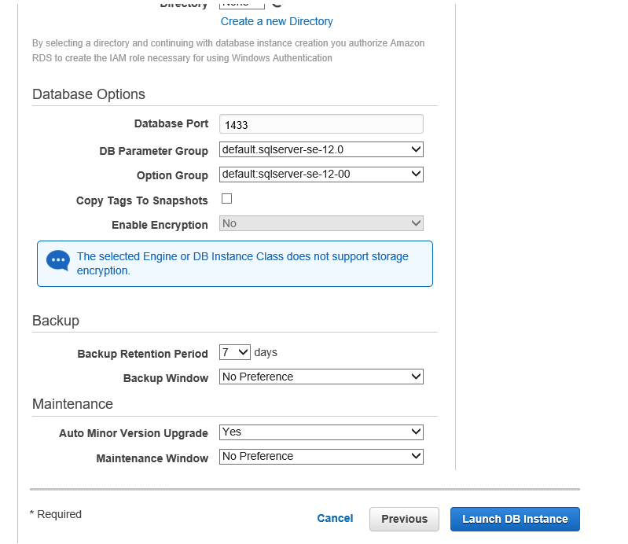

Click “Launch DB Instance”

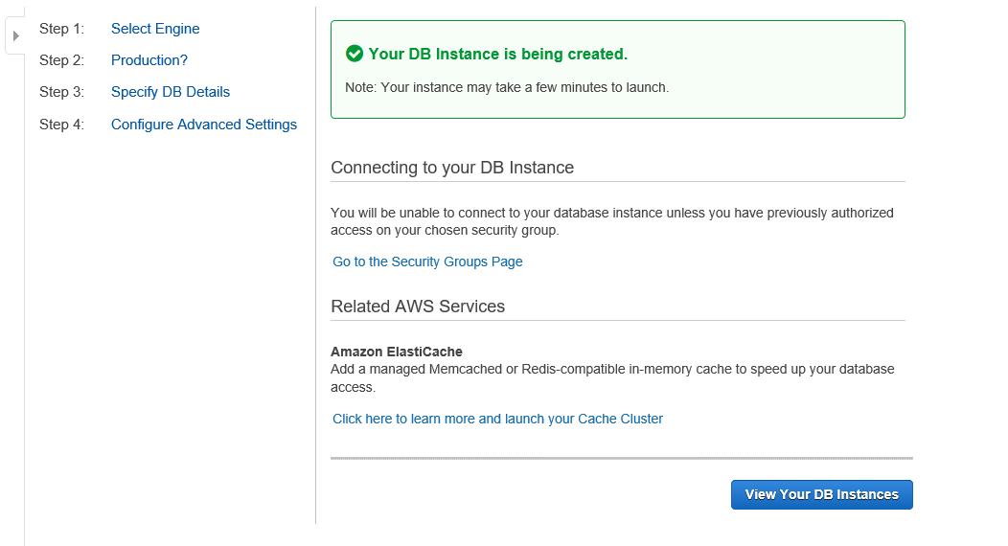

After finished, click “View Your DB Instances”

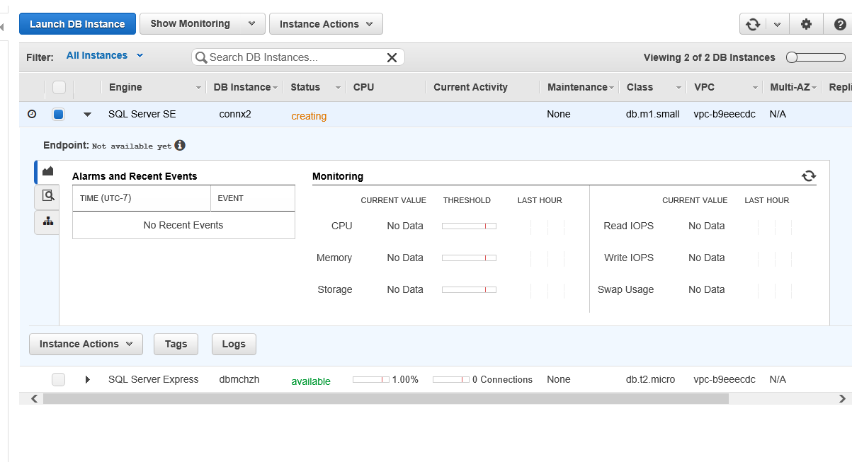

Shows instance is creating

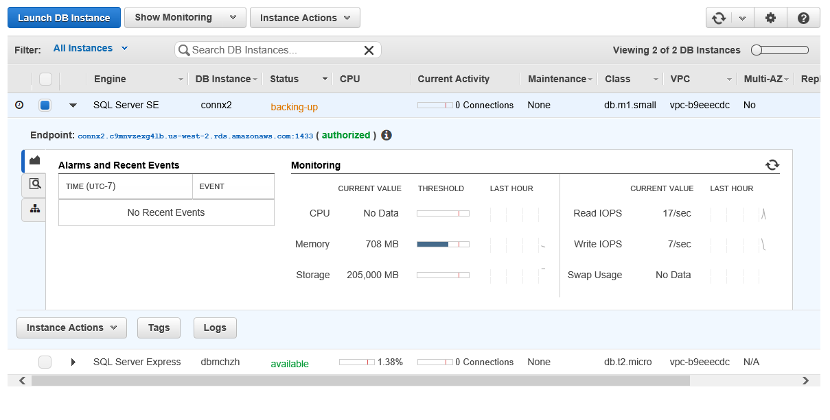

About after ten minutes, Status change as backing-up

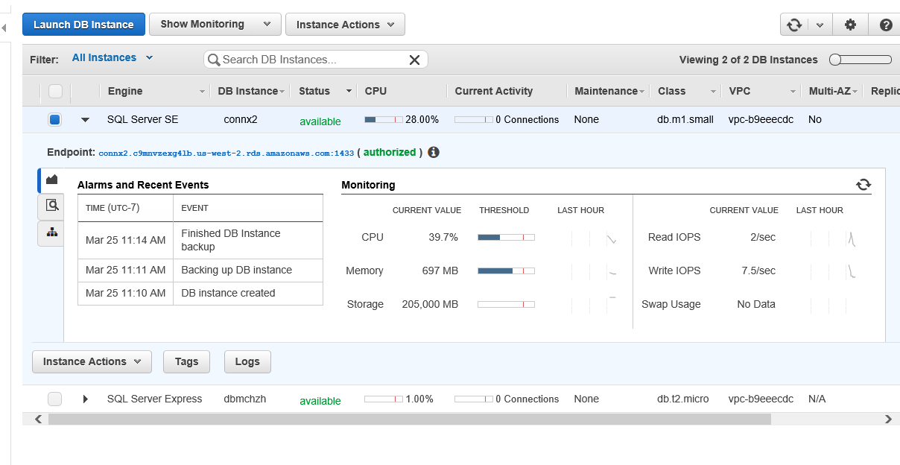

If status is “available”, it shows the instance has crested and can be used.

Click search icon button in left-middle part to get more details is:

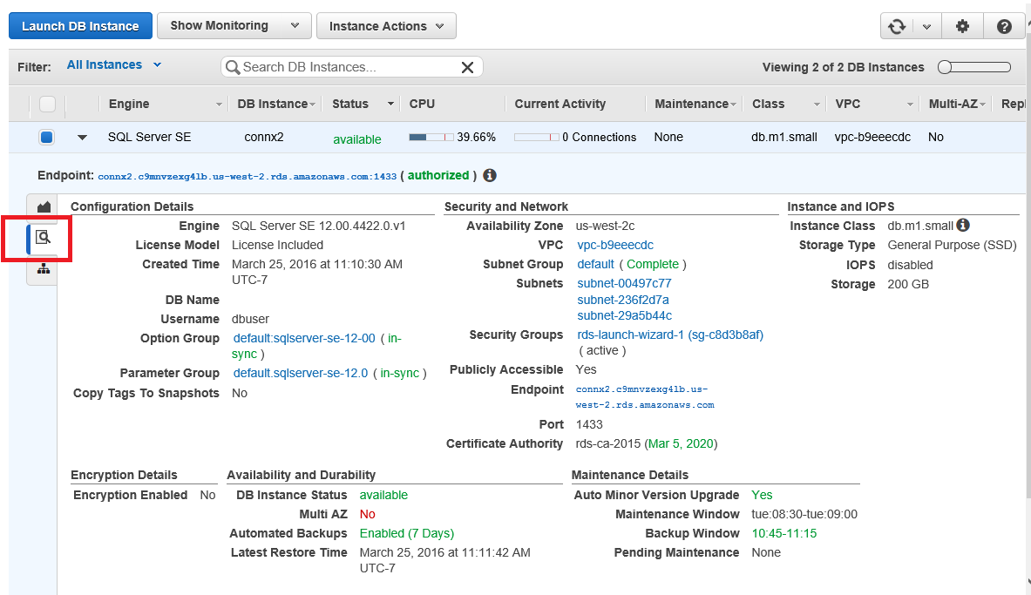

By clicking “Instance Actions” button, you can process some operation for this instance like modify, reboot or delete, etc. 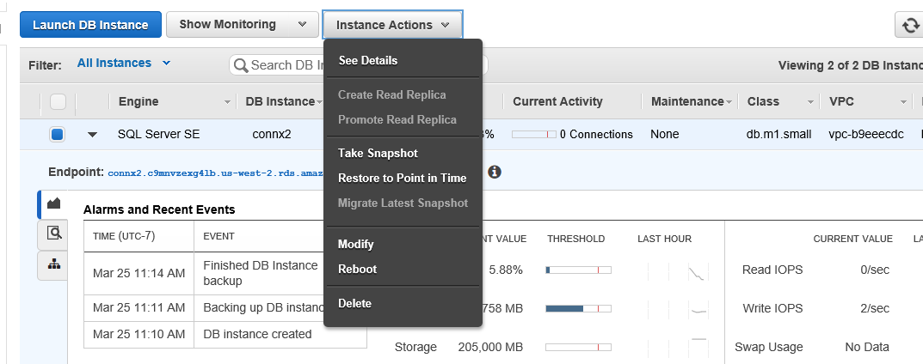

Connection info:

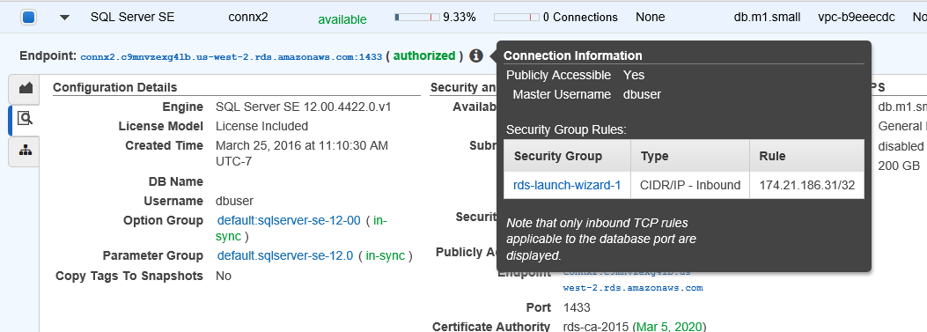

Delete instance:

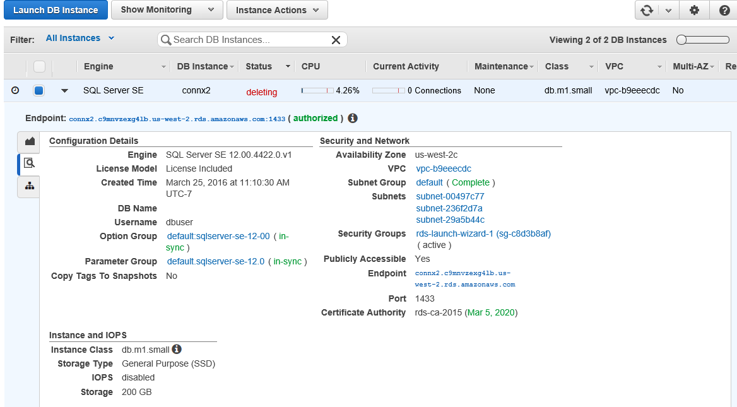

1. **How to connect AWS DB instance with SQL Server?**

Before connect to a DB instance, it needs make sure the security group of this instance permit your machine to visit this instance.

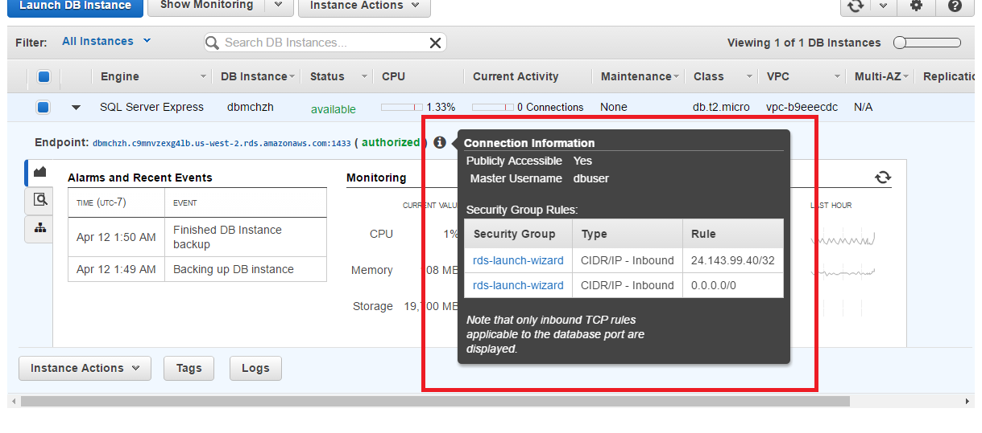

Click the specific security group name and go into setting page. Then select a group to click “Inbound” property and to add an accessible rule:

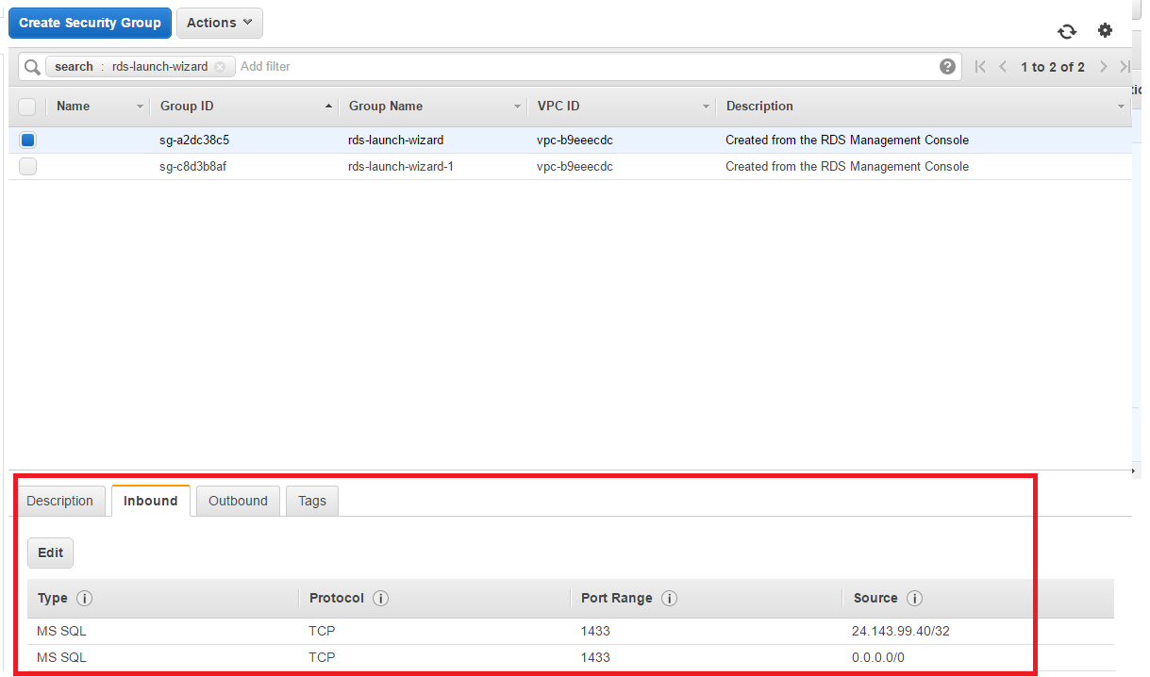

To connect this instance can reference this url:

<http://docs.aws.amazon.com/AmazonRDS/latest/UserGuide/USER_ConnectToMicrosoftSQLServerInstance.html>